Invitational Report: Trevor Blackwell
Trevor Blackwell
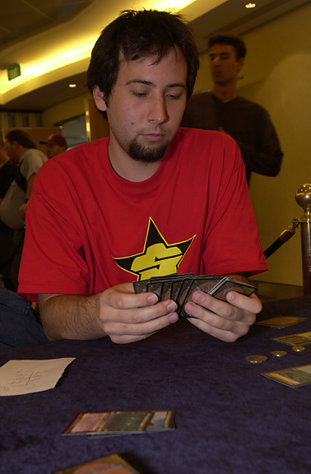
The Invitational is a great tournament in so many ways. Given to the top players in the game, this event is like no other. It offers so much to its invitees. I really hope that the Invitational stays around as long as competitive Magic does. Without it, so much would be lost.
The Location: This year it was Sydney, last year Malaysia, the year before that I believe it was in Rio. My goodness Rio! What I wouldn't have done for a free trip there. Anyway, the Invitational takes players to some of the nicest places in the world and it's all paid for. I would think that myself and most Magic players short of Ryan Fuller, could not bring themselves to drop a couple of thousand dollars for a week in some exotic city. Well thanks to the Invitational, we don't have to have a special experience can be had and remembered for a lifetime. Sydney was great, despite the bad weather, there were many beautiful sites to been seen such as the famous Opera House and Sydney's botanical garden. The nightlife was tons of fun as well offering many bars, clubs and casinos all very different from your typical American style, well except for the Casino, although it did feature the main attraction "Heads or Tails game" and yes it involved flipping a coin.
The Food: Sydney had some very tasty seafood but overall their dishes were not that different from ours; I'm sure some of the past Invitational spots offered more of a unique variety. However, most of the dinners are paid for so you can experience foreign foods to the fullest.
The Formats: Magic doesn't get any more fun than this. My favorite format, "Auctions of Champions" (you bid for a deck that has won a major tournament), found me playing Alexander Blumke's Necro deck minus the Necros. It was still a beating of a deck featuring Specters, Vampires, and Hymns. It even splashed white for a single Balance to make the players of today proud, not a bad idea from a guy in '95. Playing this deck was so great as it was extremely similar to the very first deck I played in a tournament back when Magic was at it's best. I even got the opportunity to beat Bob Maher Jr. playing the oldest version possible of blue/white control. Type 1 was almost as fun and Duplicate Sealed Deck along with Solomon draft were both great formats allowing skill to make a big appearance.
Making a card: What a fitting prize to award the player who can come out on top of this one. Immortalizing yourself in a creative way, how nice. In designing my card, I didn't shoot for anything at all creative or clever, instead I went for sheer playability and maybe card value. It would be a land that comes into play with 3 counters on it, you Tap and remove a counter to add 1 mana of any color. Or just tap to add a colorless mana to your pool. They probably wouldn't have made it anyway. Good luck to Finkel and the success of his card seeing print
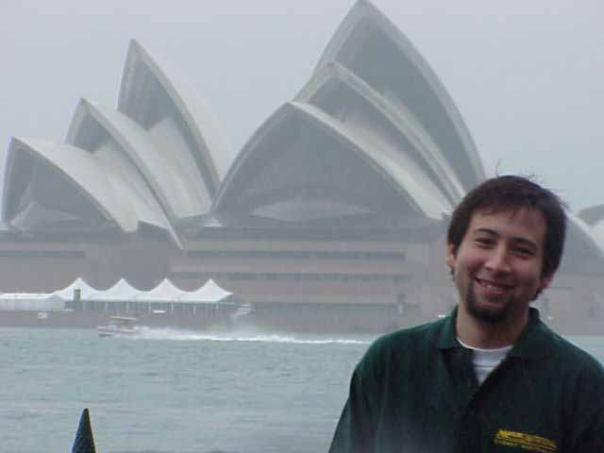
The Players: I have played in almost a dozen Pro Tour events now and all of the top players that I have faced in those did not equal that of the Invitational. The Competitors in this tournament are all near-masters and never will you even come close to having so much competition. How nice it was to Solomon draft against Mike Long and Gary Wise, to destroy Darwin Kastle in the Duplicate Sealed Round. The entire weekend you are faced up against great strategists and you have to earn every match. You also are given the opportunity to meet and get to know the top players in the game who which you will hopefully be competing against for years or at least many months to come.
Well that's my breakdown.

